  L1 Su23

Q1:

Software Requirements Specification

for

FU Library Management System ( FULIBOL) Website

Version 1.0 approved

Prepared by

HOANG THANH TUAN – SE160612

FU HO CHI MINH

24 / 07 /2023

Q2:

1. In this exam paper, the name of the rectangle is FU Librry Management system ( FULIBOL) website
2. Name of >= actors :

Student

Teacher

Librarian

Admin

1. Name of >=5 use case :

Import data on student list from fap.fpt.edu.vn

Sign in by use fpt email account of student, teacher, librarian

Exchange data book

See the News on update book

Search book

Receive notification email 3days before deadline borrow book

See list books borrow and deadline returning them

Reset deadline borrow book

Record history of book

Add new book

Import book

Usecase diagram

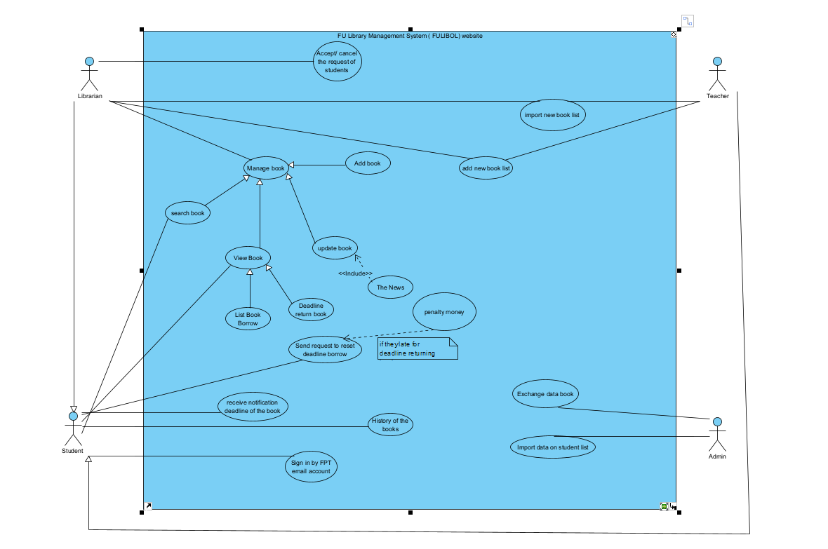

Q3:

< Student must replace this line, answer of Q3 by fill the content to below table that reflect this exam paper>

|  |  |  |  |
| --- | --- | --- | --- |
| UC ID and Name: | FU Library Management System ( FULIBOL) website 01 – create an order | | |
| Created By: | HOANG THANH TUAN | Date Created: | 24/07/2023 |
| Primary Actor: | Librarian | Secondary Actors: | Students, teachers |
| Trigger: | When the user want to borrow some book from FULIBOL | | |
| Description: | FULIBOL help students, teacher and Librarians managa all of the book they want to know and borrow from the Library | | |
| Preconditions: | 1. Has to sign in by FPT email Account 2. Choose the book want to borrow 3. Returning tem before deadline | | |
| Postconditions: | 1. Books have returning to library 2. The Librarian add new book to the FULIBOL 3. The Librarian can accept / cancel the request borrow or reset deadline | | |
| Normal Flow: | 1. Login 2. Manage book 3. CRUD book 4. Request to reset deadline book 5. View history book 6. Add new book to book list 7. Notification email | | |
| Alternative Flows: | 1. Send email to penalty money 2. Accept/cacel deadline book | | |
| Exceptions: | 1. …..(0.3 point) Describe the sequence of steps that can be handled or implemented when there are any exceptions. 2. … 3. … | | |
| Priority: | Medium | | |
| Frequency of Use: | High | | |
| Business Rules: | Can’t not late deadline book  Sign in by FPT email Account | | |
| Other Information: | (0.1 point) It may be described the quality here for more info. | | |
| Assumptions: | (0.1 point) The assumptions on the data related to this use case. | | |

**Q4:**

< Student must replace this line, the answer of Q4 must have detail and specific in number of 2 non-functional requirements for FULIBOL>